REQUEST:

1)Application Layer Header
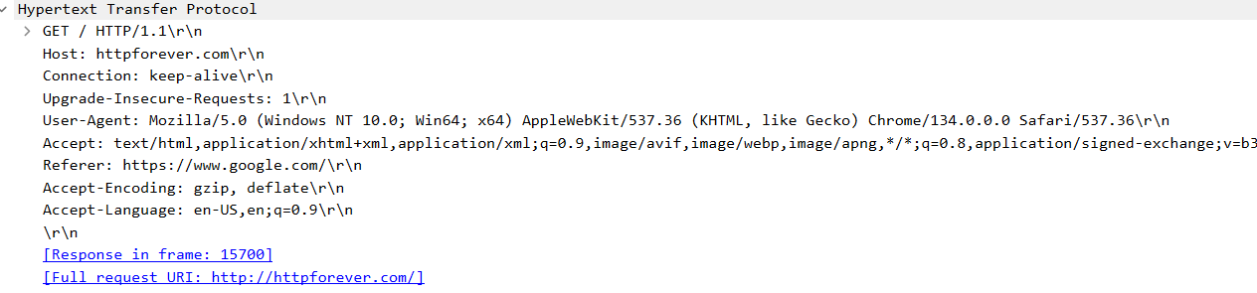
It has the request line which shows requested Method and HTTP version. Again, it consist Host, User agent, Connection etc.

2)Transport Layer Header
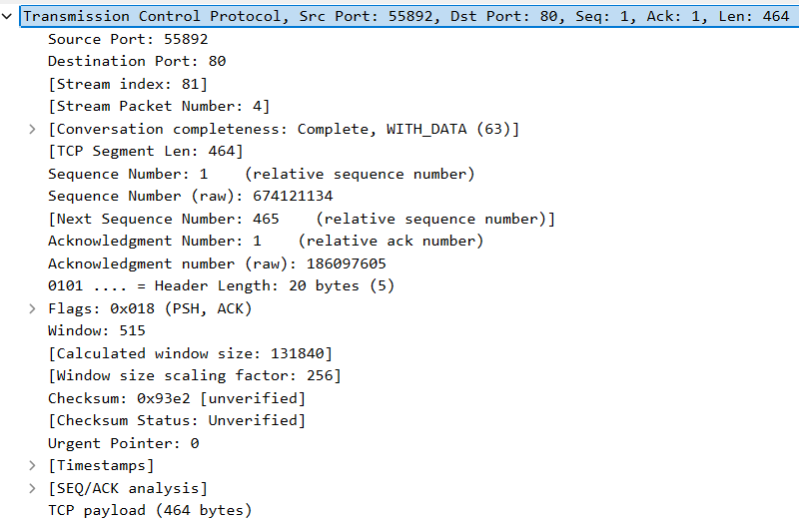
It consists the source and destination port number of sender and receiver respectively. It also has sequence number and acknowledgement number for reliable data transfer.

3)Network Layer Header
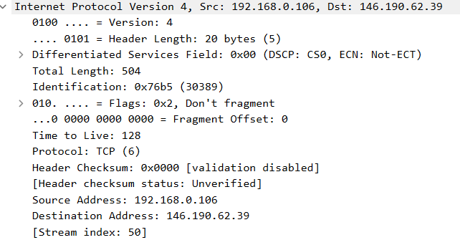
It consists the source and destination IP address of sender and receiver respectively. Again, there is different fields header length, time to live, IP version. Also, checksum is used for error detection.

4)Data-Link Layer Header
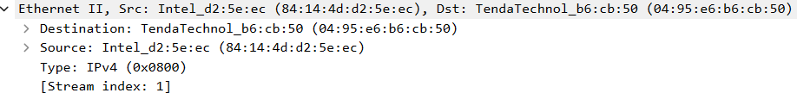
It consists the source and destination MAC address of the sending and receiving device. Also, it contains the type of protocol.

5)Physical Layer Header
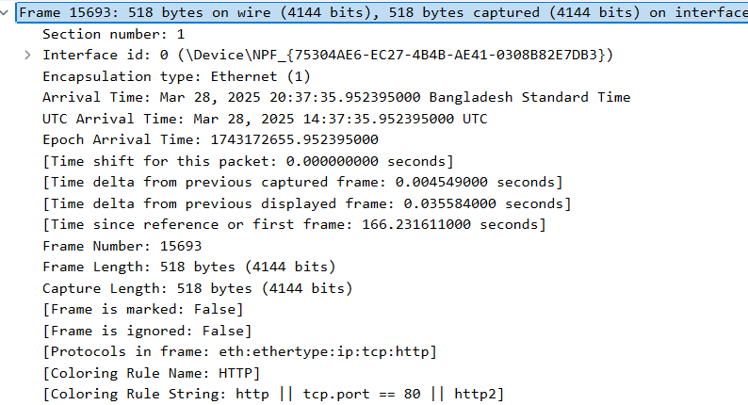
It consists the transmitted binary bits and encapsulation type.

RESPONSE:

1)Application Layer Header
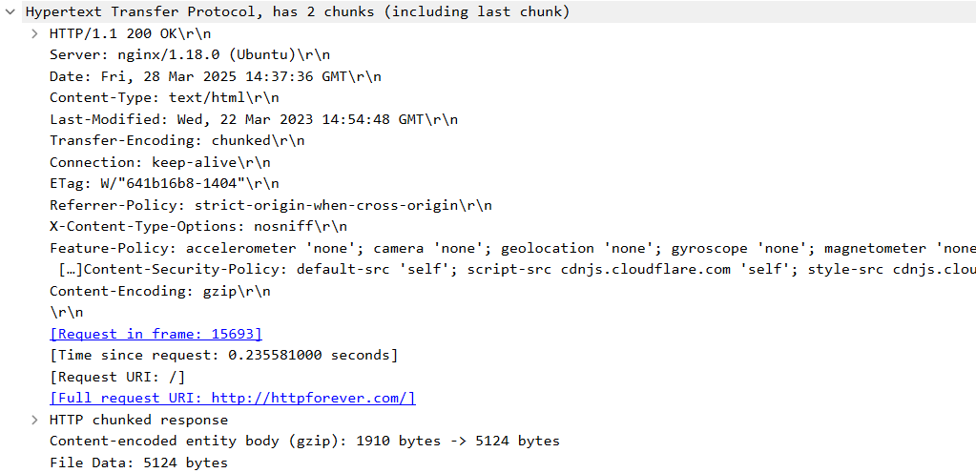
It consists the status line which shows the status code, status message and HTTP version. Again, it has fields like date, server, content length, connection etc.

2)Transport Layer Header
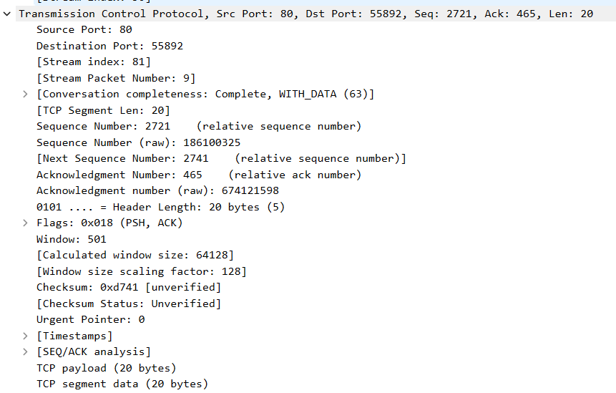

In the response packet source and destination port number of sender and receiver are switched. It also has sequence number and acknowledgement number for reliable data transfer.

3)Network Layer Header
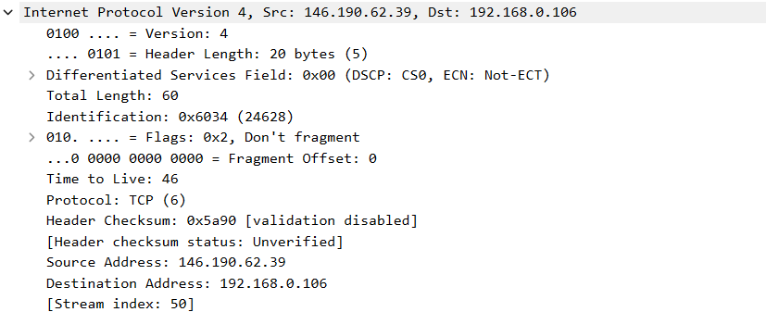
In the response packet source and destination IP address of sender and receiver are switched. Again, there is t field’s like header length, time to live, IP version. Also, checksum is used for error detection.

4)Data-Link Layer Header
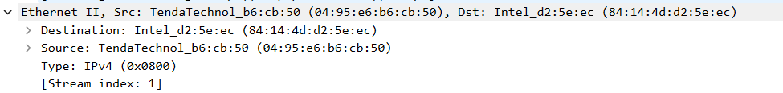
It consists the source and destination MAC address of the sending and receiving device. Also, it contains the type of protocol.

5)Physical Layer Header
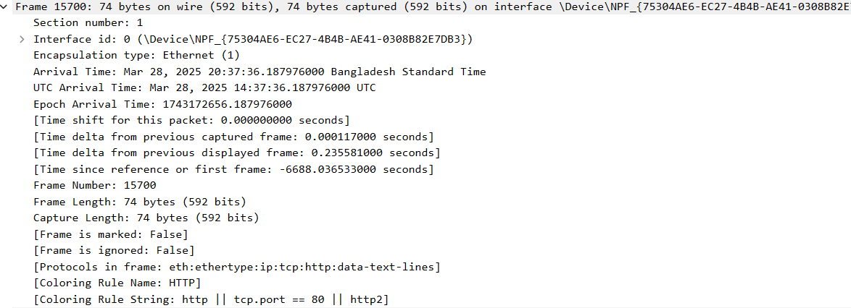

It consists the transmitted binary bits and encapsulation type.

